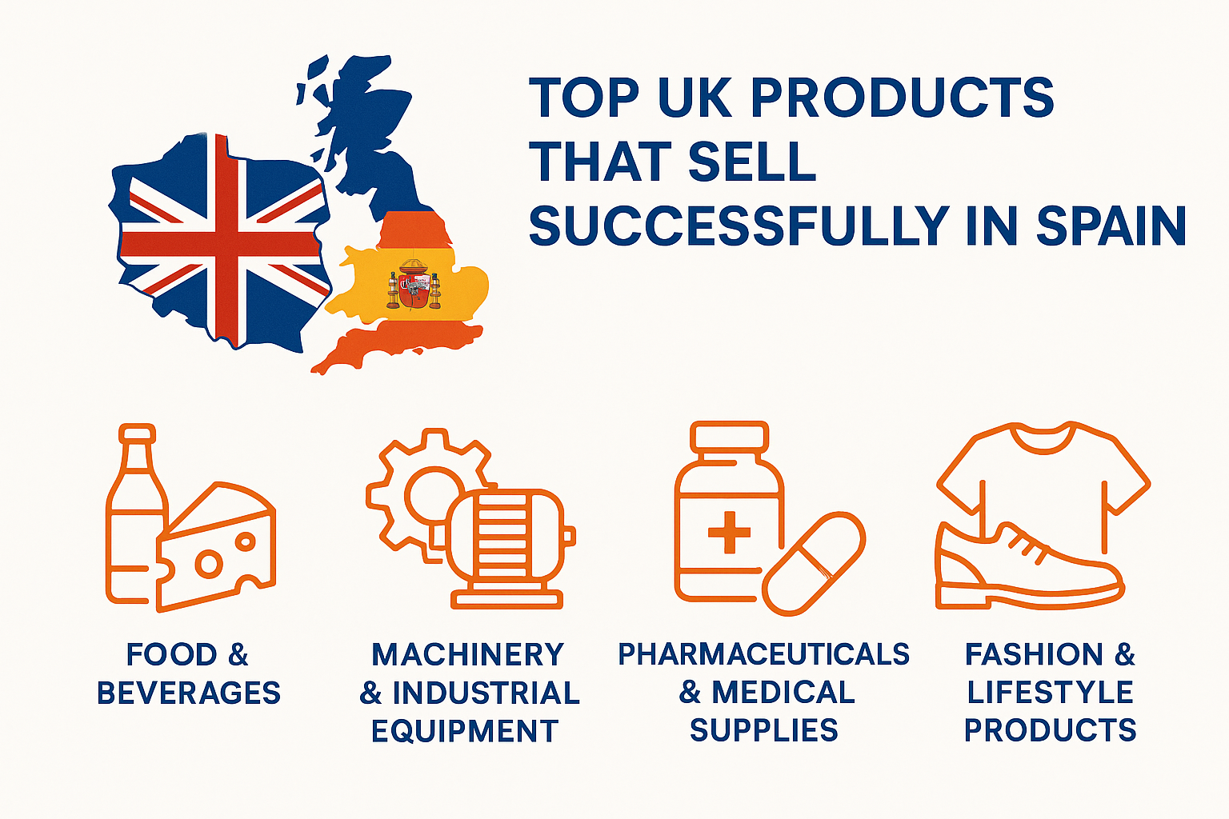

**Top UK Products That Sell Successfully in Spain — And How Trade Link Helps You Expand**

***British innovation meets Spanish opportunity.***

The trade relationship between **the United Kingdom and Spain** continues to thrive, with British exports finding strong demand across a wide range of Spanish industries. From technology and pharmaceuticals to food, fashion, and professional services — **UK-made products** hold a reputation for **quality, reliability, and innovation**.

But entering or expanding in the Spanish market requires more than great products — it requires understanding the local business landscape, navigating customs, and building the right partnerships. That’s where **Trade Link** comes in.

**🇬🇧✨ 1. Food & Beverages — A Taste of British Quality**

British food and drink products are making their mark in Spain, especially among high-end retailers and specialty importers.

**Popular UK exports to Spain include:**

* **Whisky, gin, and craft beers** — British spirits are loved by Spanish distributors and hospitality chains.
* **Snacks, biscuits, and sauces** — British FMCG brands often appeal to expats and locals seeking premium options.
* **Dairy and processed foods** — Quality cheese, butter, and packaged goods find stable demand in Spanish retail.

**How Trade Link helps:**  
We assist UK food exporters with **IPAFFS and CHED documentation**, customs clearance, and distributor introductions — ensuring your products reach Spanish shelves smoothly and compliantly.

**⚙️ 2. Machinery & Industrial Equipment**

Spain’s industrial and construction sectors rely heavily on advanced **British machinery and tools**.

**Top exports include:**

* Engineering tools and industrial machinery
* Electrical and energy equipment
* Renewable technology and components

These products are valued for their durability and precision — qualities that give British manufacturers an edge in Spain’s expanding infrastructure and energy markets.

**How Trade Link helps:**  
We manage **customs documentation, T1 transit forms**, and **EUR.1 certificates** for smooth movement of machinery across borders — saving you time and costs on every shipment.

**💊 3. Pharmaceuticals & Medical Supplies**

The UK’s strong pharmaceutical and life sciences industries make it a key supplier to Spanish healthcare markets.

**Exports in demand:**

* Medical instruments and devices
* Pharmaceutical compounds and supplements
* Diagnostic equipment and hospital consumables

Post-Brexit, many suppliers face challenges with **certifications and customs compliance**, but these can be overcome with the right guidance.

**How Trade Link helps:**  
We streamline the process with **customs compliance expertise** and **market entry support**, ensuring your goods meet both UK and EU regulations.

**👕 4. Fashion & Lifestyle Products**

British fashion brands — known for design, craftsmanship, and heritage — have found eager customers in Spain’s retail sector.

**Top performers include:**

* Sustainable fashion brands
* Footwear and accessories
* Designer apparel and luxury goods

Spanish consumers appreciate UK-made products for their originality and quality, particularly in premium retail and online channels.

**How Trade Link helps:**  
We connect UK designers with Spanish distributors and e-commerce partners, managing **B2B introductions, customs clearance, and logistics** for seamless trade.

**🚗 5. Automotive Parts & Technology**

British-made **auto parts and engineering solutions** are in consistent demand across Spain’s thriving automotive and transport industries.

**Common exports include:**

* Vehicle components and electronics
* Lubricants and maintenance products
* Performance and aftermarket parts

**How Trade Link helps:**  
From **transport logistics to customs clearance**, our team ensures your automotive goods reach Spanish clients efficiently — compliant, traceable, and on schedule.

**🌍 Trade Link — Your Bridge Between the UK and Spain**

Whether you’re a new exporter or already shipping to Europe, **Trade Link** provides end-to-end solutions:

* Market research & entry strategy
* Trader connections & partnerships
* Transport & customs management

We simplify the process so you can focus on what matters most — growing your business.

**🚀 Ready to Expand Your UK Products into Spain?**

The Spanish market is open, active, and waiting for British brands with quality and ambition.  
With **Trade Link**, you gain a partner that connects opportunities and delivers results.

**Trade Link — Connecting Markets. Moving Opportunities.**  
📩 Contact us today to start exporting smarter.